The Empire State Snowshoe Series

Presents…
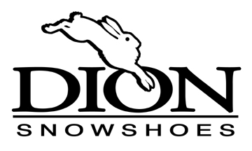

Race 1: | December 3, 2016 | Jingle Bell 5K and 10K | VIC at Paul Smith’s
Race 2: | January 7, 2017 | Frozen Assets 5K | Honeoye, NY
Race 3: | January 14, 2017 | Beak n Skiff 5K | Layfayette, NY
Race 4: | January 15, 2017 | Winterfest 8K | Mendon Ponds Park
OR… | January 15, 2017 | CockaDoodle Shoe 5K/10K | Saranac, NY
Race 5: | January 22, 2017 | Oak Mountain 5K/10K | Speculator, NY
Race 6: | January 28, 2017 | The Stone Wall 5K/15K | Mannsville, NY  Winona Forest
Race 7: | February 4, 2017 | Super Frosty Loomis 5K/10K | Ithaca, NY  Hammond Hill State Forest
OR… | February 4, 2017 | Empire State Games | NY
Race 8: | February 5, 2017 | Selkirk 5K | Selkirk State Park, NY
Race 9: | February 11, 2017 | Natural Stone Bridge 3-4 Miler | Pottersville, NY
Race 10: | February 18, 2017 | SnoFatShu 5K (and Winter Duathlon) | Mannsville, NY  Winona Forest
Race 11: | March 5, 2017 | Dewey Mountain Challenge | Saranac Lake, NY
Our 13 individual snowshoe races (11 possible races for points) are collectively organized as a series. Individual points awarded for each race using a very simple scoring system. Your best 6 individual performances in series races will determine the individual standings. Top 3 in the Open and Master’s division will be awarded. Additionally, anyone completing 6 or more races will be eligible for raffle prizes donated by Dion Snowshoes, including 2 pairs of Dion racing snowshoes. For 2017, prizes will be awarded at the Dewey Mountain Challenge race March 5. For details, FAQ’s, race schedule, points standings, and other information, visit the Winona Forest Recreation website at www.winonaforest.com, click on DION NY SNOWSHOE SERIES
2016-2017 Schedule

